**Notes**

Declaration at the top

Then do usage later

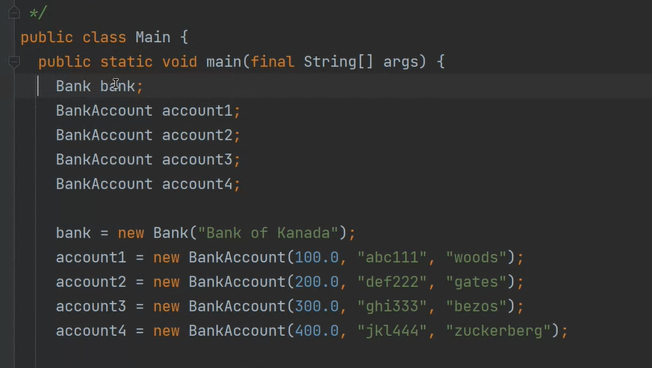

Set is uppercase

Anything with uppercase is a reference type

References to objects:

* HashMap
* Map

Setup assignment

Files > project structure